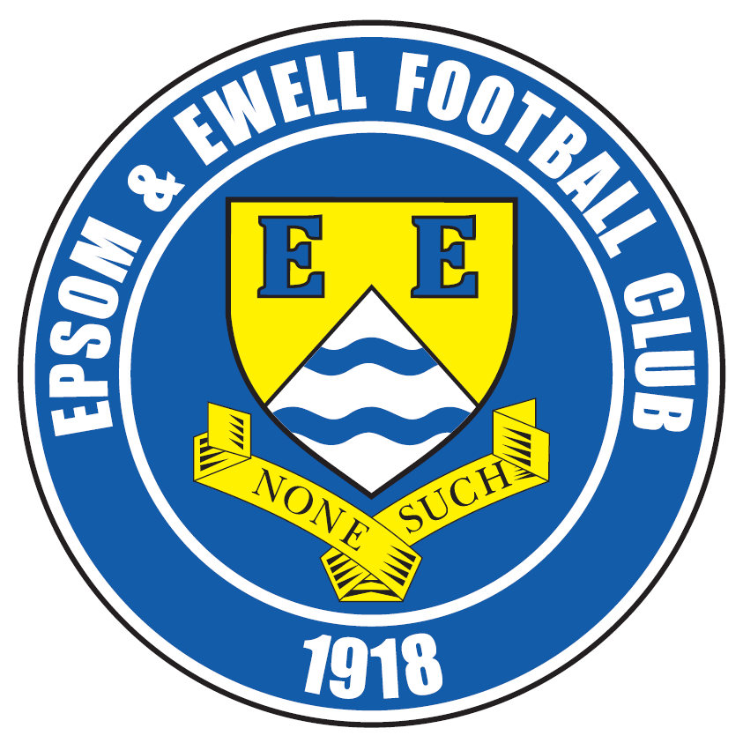 | Epsom & Ewell F.C.  6  v  Hanworth Villa  Saturday, 23rd September 2017 – 3.00 p.m.
Good afternoon and welcome to High Road for our latest League match. We welcome the players, supporters and officials of Hanworth Villa and wish them a safe journey home.

We also say hello to our former keeper Michael Eacott, his dad Steve and grandfather Brian who were regulars at our games over the last three years. In fact, in recent years we have seen a few player movements between the two teams with Alex Rodrigues, Dale Marvell, Alex McGregor and more recently Tom Neale making the journey.

We required a very late equaliser to secure a 2-2 draw at home against our opponents last December, but lost narrowly to an early goal in the return in January, although we did win in the League Cup after extra time by four goals to two, so it was very much honours even in the end.

Our last match here resulted in a 2-3 defeat to Horley Town and whilst we scored first and last in the match, they were too strong for us in the second half. If we had taken our chances in the first forty-five we could have built a healthy lead, but it wasn’t to be. Then last Saturday we visited Farnham Town for our 4,000th competitive match, and secured our second point of the season from a 0-0 draw. A full article about our significant milestone will follow in our next programme, which should be a rather large issue!

We have a number of away trips now coming up. Firstly, we visit Worcester Park in the First Round of the League Cup next Saturday. They have no lights which is why the match is on a Saturday, but the kick off remains at 3pm. The Saturday after that we visit Knaphill, who have been had a fine run in the F.A. Cup this year but their League form has been patchy. If we beat Worcester Park at Green Lane, we would visit either CB Hounslow United or Eversley & California in the Second Round on Tuesday 10th October. They meet this coming Tuesday.

On Saturday 14th October we visit Camberley Town for a League match and then seven days later we play in the F.A. Vase First Round. Our opponents will not be known until Monday so we don’t yet know whether we are at home or away! The only thing we know for certain from this point is that we will definitely host North Greenford United on Saturday 28th October. Please keep checking the website and our social media links for up to date details.

To sponsor a match and match ball costs £55 but this does include free entry for three people, including programmes and hospitality. Alternatively, you can sponsor a player at £40 a time, so please help our club by letting a Committee member know. The new list will be available shortly.

Enjoy the game.

Rich

Don’t forget, you can follow us on Facebook: www.facebook.com/epsomandewellfc
Twitter: @EEFCOfficial Instagram at: www.instagram.com/epsomandewellfc
and Youtube at: www.youtube.com/channel/UCtLrpS0x5OaYUACRT34_zng

Cover photos by Gemma Jarman

- Our boys line up for our 4,000th match at Farnham Town last Saturday

- Joe Loftus-Cheek gets a good look at the ball on Saturday at Farnham


Cherry Red Records Combined Counties League
Premier Division Table 2017/18
inc Tuesday 19th Sept | P | W | D | L | F | A | Pts | GD | H | A
Westfield | 9 | 8 | 1 | 0 | 40 | 8 | 25 | +32 | 14/4 | 9/12
Walton & Hersham | 8 | 6 | 1 | 1 | 20 | 6 | 19 | +14 | 30/12 | 21/4
Bedfont Sports | 7 | 6 | 1 | 0 | 21 | 10 | 19 | +11 | 24/3 | 4/11
Colliers Wood United | 9 | 5 | 2 | 2 | 20 | 9 | 17 | +11 | 30/3 | 2-5
Spelthorne Sports | 9 | 5 | 1 | 3 | 21 | 15 | 16 | +6 | 1-5 | 27/1
Horley Town | 8 | 5 | 0 | 3 | 13 | 12 | 15 | +1 | 2-3 | 23/12
Guildford City | 6 | 4 | 0 | 2 | 7 | 4 | 12 | +3 | 2/12 | 7/4
Camberley Town | 7 | 3 | 2 | 2 | 11 | 11 | 11 | 0 | 10/3 | 14/10
Sutton Common Rovers | 7 | 3 | 1 | 3 | 11 | 9 | 10 | +2 | 3/2 | 0-5
Chertsey Town | 9 | 3 | 1 | 5 | 16 | 22 | 10 | -6 | 2-7 | 31/10
Redhill | 8 | 3 | 1 | 4 | 16 | 15 | 10 | +1 | 0-5 | 6/1
Balham | 7 | 3 | 1 | 3 | 10 | 14 | 10 | -4 | 20/1 | 25/11
Abbey Rangers | 7 | 3 | 1 | 3 | 9 | 13 | 10 | -4 | 16/12 | 17/2
Hanworth Villa | 8 | 2 | 3 | 3 | 13 | 15 | 9 | -2 | 23/9 | 10/2
CB Hounslow United | 7 | 2 | 2 | 3 | 13 | 12 | 8 | +1 | 13/2 | 2-4
Knaphill | 6 | 2 | 1 | 3 | 10 | 17 | 7 | -7 | 24/2 | 7/10
North Greenford United | 7 | 0 | 5 | 2 | 7 | 11 | 5 | -4 | 28/10 | 17/3
Farnham Town | 7 | 1 | 2 | 4 | 9 | 15 | 5 | -6 | 14/11 | 0-0
Godalming Town | 8 | 1 | 2 | 5 | 8 | 22 | 5 | -14 | 11/11 | 13/1
AFC Hayes | 7 | 1 | 1 | 5 | 9 | 13 | 4 | -4 | 28/4 | 18/11
Banstead Athletic | 6 | 1 | 1 | 4 | 4 | 10 | 4 | -6 | 2/4 | 1-1
Epsom and Ewell | 9 | 0 | 2 | 7 | 10 | 35 | 2 | -25 | X | X
1

Lucky Day? – 23rd September
Played 16 - Won 6 Drawn 4 Lost 6 - For 24 Against 34 - PPG 1.50 - Average
Our Club record against today’s opponent
Played 17 - Won 8 Drawn 4 Lost 5 - For 40 Against 29 - PPG 1.65 - Above Average
Our Largest wins and losses against today’s opponent
21st November 2015 - W 5-0 - Combined Counties League (H)
26th April 2014 - L 1-4 - Combined Counties League (H)
Their Last Visit
13th December 2016 - Drew 2-2 - Combined Counties League

Results and Fixtures so far
F.A. Vase – First Qualifying Round – Sunday 10th September
Ascot United | 1-3 | Farnham Town
F.A. Vase – First Qualifying Round Replay – Tuesday 12th September
Hatfield Town | 0-3 | AFC Hayes
Combined Counties League – Tuesday 12th September
Epsom & Ewell | 2-3 | Horley Town
Godalming Town | 1-3 | Colliers Wood United
Hanworth Villa | 1-5 | Westfield
Knaphill | 1-5 | Walton & Hersham
North Greenford United | 1-1 | Spelthorne Sports
Redhill | 2-0 | Guildford City
Combined Counties League – Friday 15th September
Colliers Wood United | 1-2 | Balham
Emirates F.A. Cup Second Qualifying Round – Saturday 16th September
Bath City | 6-0 | Knaphill
Combined Counties League – Saturday 16th September
AFC Hayes | 2-3 | Westfield
Camberley Town | 2-3 | Bedfont Sports
CB Hounslow United | 3-0 | Godalming Town
Chertsey Town | 4-2 | Redhill
Farnham Town | 0-0 | Epsom & Ewell
Guildford City | 2-0 | Abbey Rangers
North Greenford United | 0-1 | Walton & Hersham
Spelthorne Sports | 0-1 | Horley Town
Sutton Common Rovers | 1-0 | Banstead Athletic
Combined Counties League Cup 1st Round – Monday 18th September
Sutton Common Rovers | 3-1 | Westfield
Combined Counties League Cup 1st Round – Tuesday 19th September
Camberley Town | 0-3 | Redhill
Frimley Green | 1-4 | Cobham
Raynes Park Vale | 3-2 | Hanworth Villa
South Park Reserves | 3-4 | Horley Town
Combined Counties League – Tuesday 19th September
Banstead Athletic | 0-3 | Colliers Wood United
Walton & Hersham | 7-0 | Chertsey Town
Combined Counties League Cup 1st Round – Wednesday 20th September
FC Deportivo Galicia | 1-0 | AC London
Results and Fixtures so far
F.A. Vase Second Qualifying Round – Saturday 23rd September
AC London | V | Horley Town
Balham | V | Forest Hill Park
Buckingham Athletic | V | AFC Hayes
Chippenham Park | V | Camberley Town
Glebe / Deal Town | V | CB Hounslow United
Godalming Town | V | Brockenhurst
Hassocks | V | Spelthorne Sports
K Sports | V | Abbey Rangers
Knaphill | V | Horndean
Sporting Club Thamesmead | V | Walton & Hersham
Warminster Town | V | Farnham Town
Combined Counties League – Saturday 23rd September
Banstead Athletic | V | Chertsey Town
Epsom & Ewell | V | Hanworth Villa
Guildford City | V | Bedfont Sports
Combined Counties League Cup 1st Round – Tuesday 26th September
CB Hounslow United | V | Eversley & California
Combined Counties League – Tuesday 26th September
Banstead Athletic | V | Guildford City
Camberley Town | V | Walton & Hersham
Horley Town | V | Colliers Wood United
Knaphill | V | North Greenford United
Redhill | V | Farnham Town
Combined Counties League Cup 1st Round – Saturday 30th September
Staines Lammas | V | Chertsey Town
Worcester Park | V | Epsom & Ewell
Combined Counties League – Saturday 30th September
AFC Hayes | V | Knaphill
Bedfont Sports | V | Horley Town
Camberley Town | V | Abbey Rangers
CB Hounslow United | V | Guildford City
Colliers Wood United | V | Spelthorne Sports
Farnham Town | V | Banstead Athletic
Godalming Town | V | Walton & Hersham
Hanworth Villa | V | Balham
North Greenford United | V | Redhill
Sutton Common Rovers | V | Westfield
Results and Fixtures so far
Combined Counties League Cup 2nd Round – Tuesday 3rd October
Bedfont Sports | V | Farleigh Rovers
Combined Counties League – Tuesday 3rd October
Godalming Town | V | Camberley Town
Hanworth Villa | V | Knaphill
Walton & Hersham | V | Guildford City
Combined Counties League Cup 2nd Round – Wednesday 4th October
Cove | V | Sutton Common Rovers
Combined Counties League – Friday 6th October
Colliers Wood United | V | Sutton Common Rovers
Combined Counties League – Saturday 7th October
AFC Hayes | V | Balham
Abbey Rangers | V | Hanworth Villa
Banstead Athletic | V | Godalming Town
Chertsey Town | V | CB Hounslow United
Guildford City | V | Farnham Town
Horley Town | V | North Greenford United
Knaphill | V | Epsom & Ewell
Redhill | V | Bedfont Sports
Spelthorne Sports | V | Camberley Town
Walton & Hersham | V | Westfield
Combined Counties League Cup 2nd Round – Tuesday 10th October
Abbey Rangers | V | FC Deportivo Galicia
AFC Hayes | V | Cobham
Bagshot | V | North Greenford United
Banstead Athletic | V | Farnham Town
Bedfont & Feltham | V | Godalming Town
Redhill | V | Fleet Spurs
CB Hounslow Utd / Eversley & C | V | Worcester Park / Epsom & Ewell
Chessington & Hook United | V | Sheerwater
Knaphill | V | Guildford City
Spelthorne Sports | V | Ash United
Staines Lammas /  Chertsey Town | V | Horley Town
Walton & Hersham | V | Badshot Lea
Combined Counties League – Saturday 14th October
Camberley Town | V | Epsom & Ewell

From behind the goal
Epsom & Ewell 2-3 Horley Town
Combined Counties League - Premier Division - Tuesday 12th September 2017

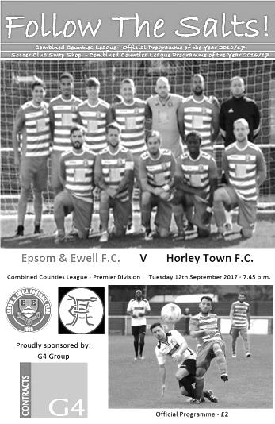
A missed opportunity on a horrible evening

A healthy attendance of 66 on a miserable evening of driving wind and rain were rewarded with probably the most entertaining match of the season, although unfortunately it was the visitors who took the points, largely as a result of an improved second half performance

After our defeat on Saturday we made only two changes to the starting eleven, with Reisse Griffin coming in for the injured David Thomson and Colin Harris replacing Andy Smith in goal and we got off to a flying start. With the clock showing the fourth minute Rob Hendry got away down the left hand side and delivered the ball. Only he will know whether it was a cross or a shot from that narrow angle but it caught visiting keeper Andrew Osai out and he was only able to lay half a glove on it as it flew into the net.

It must be mentioned that Harris had already made a low save with his feet from Alex Barbary's low shot or we would have conceded very early once again, but fortune favoured us at this stage. Would we be able to capitalise on the early lead? We had a great opportunity to do just that as Hendry set up Scott Murphy on the left and his delivery was heading towards Ashley Thompson at the far post but at full stretch, our man was unlucky to see his shot from six yards out just clear the bar as he caught it on the half volley.

Of course it wouldn't be an Epsom game without some customary scares at the other end and Ben Hayward had to be alert to clear the danger after Harris had made a good low save before another shot came in from the left that Harris held cleanly. The ball was skidding along on the very wet surface and a right wing cross connected with the arm of Hayward and resulted in a penalty being awarded with Kerran Boylan calmly tucking it away to level the scores in the 30th minute.

In recent matches one goal being conceded would often lead to others following in quick succession but we finished the half quite well really. Another great ball in from Hendry just eluded the head of Jason Nwachukwu who was only eight yards out before Dan Rose connected really well from thirty yards with the ball clearing the crossbar by inches, although to be fair, Osei had it covered and actually got a touch to it.

Most surprisingly of all though it was Kyle Hough who missed our best chance in the 42nd minute when he beat two men before uncharacteristically lashing at the ball and

blazing over from 12 yards with just Osei to beat. At the other end a great finish by Boylan and subsequent celebrations for the visitors were chalked off by an Assistant's flag for offside.

We had arguably done enough in that first half to be ahead but within three minutes of the restart Horley had taken the lead. The ball through to Leyton Regan was finished clinically, but it was frustrating because the through ball had just slipped under the foot of one of our players. Nwachukwu responded with a 20 yarder but Osei was well behind it and we had a scare after Harris lost the ball on the edge of the area but the Horley striker was unable to take advantage as we had defenders back by then.

Worryingly we were staring to show a bit of vulnerability from corners. We hacked one ball out at the last moment from almost under the crossbar and from the next, Harris went to claim it but saw the ball fly over his head and when the ball was headed back into the danger area, it was headed against a post. Another good run from Hendry resulted in a delivery to Hough that he controlled well but was just blocked out by a defender and by the time his shot came in it was cleared by a defender. We then unnecessarily conceded another corner when a horrible back pass to Harris was sliced out and again we didn't deal with the 67th minute delivery which was headed in from close range by Karl Parker to make it 3-1.

Some of the heads began to drop at this stage. We conceded a free kick but weren't alert to the visiting player having a strike from thirty yards. Luckily Harris was able to get across to make the save. We were attacking less often at this point, although Joe Loftus-Cheek was pushed over in the box and it was one of those decisions that sometimes go your way. Ultimately, he probably went down a little too easily for the referee's liking.

One final glimmer of hope came in the 90th minute when all three of our substitutes combined to pull a goal back. Jamie Hatfield, having a quick cameo role in centre midfield initiated the move by finding Ben Dyson on the right. His ball into the channel was chased by Liam Roberts who eluded the keeper's charge out of goal and squared the ball for Sean White to knock in from close range, but it was too late to really matter and Horley nearly increased their lead at the end as we pushed for an equaliser but the shot went just wide.

On reflection Horley deserved the points and played some nice football at times, but we created a lot more in this match than in recent encounters and if we had built a lead in the first half as we maybe should have, we might well have held on to it. Worryingly though, this was the third time we had led in a league match this season, but remain at the foot of the table with just one point from our eight matches.

Epsom and Ewell: Colin Harris, Ben Dyson, Rob Hendry, Reisse Griffin, Scott Murphy, Daniel Rose, Ben Hayward (c), Ashley Thompson, Kyle Hough, Joe Loftus-Cheek,
Jason Nwachukwu

Subs: Sean White for Rose (53), Liam Roberts for Loftus-Cheek (85),
Jamie Hatfield for Nwachukwu (85)

#
Club Records - 23rd September
Date | Day | Competition |  | Opponents |  | Scorers
23/09/33 | Sat | Surrey Charity Shield 1 | H | Met Police | 4-2 | L.Graves (2), T.Dunne, L.Marlow
23/09/50 | Sat | Amateur Cup  Preliminary Round | A | Surbiton Town | 4-2 | S.Faggetter (pen), P.Jordan, B.Musto, o.g.
23/09/61 | Sat | Surrey Senior Cup 1q | A | Whyteleafe | 3-2 | R.Dowse, J.Punter, o.g.
23/09/67 | Sat | Amateur Cup  Preliminary Round | H | Ulysses | 1-1 | T.Stafford
23/09/72 | Sat | Athenian League 2 | A | Leyton | 0-4
23/09/78 | Sat | Isthmian League 1 | H | Harwich & Parkeston | 1-1 | J.Palladino
23/09/80 | Tue | Isthmian League Cup 2 | A | Worthing | 2-2+ | T.Tuite (2)
23/09/86 | Tue | Isthmian League Cup 1 | H | Southwick | 0-2
23/09/89 | Sat | Isthmian League 2s | A | Chertsey Town | 1-1 | B.Perkins
23/09/95 | Sat | Isthmian League 3 | H | Flackwell Heath | 4-3 | S.Miller (2), S.Smith, P.Meredith
23/09/00 | Sat | F.A. Vase 2q | A | Windsor & Eton | 1-0 | D.Marvell
23/09/02 | Mon | Isthmian League 1s | A | Carshalton Athletic | 0-2
23/09/03 | Tue | Isthmian League 1s | H | Ashford Town (Mx) | 0-5
23/09/06 | Sat | F.A. Vase 2q | H | Sevenoaks Town | 0-1+
23/09/08 | Tue | Combined Counties  Premier Division | A | Horley Town | 3-2 | D.Marvell (2), K.Hough (pen)
23/09/14 | Tue | Combined Counties  Premier Division | A | Westfield | 0-4
Historical Decades
90 years ago – Epsom Town F.C.
24/09/27 | Sat | London League | H | Callender Athletic | 6-4 | R.Marlow (2), J.Parr (2), F.Behn, C.Taylor
80 years ago – Epsom F.C.
25/09/37 | Sat | Amateur Cup  Preliminary Round | A | Banstead Mental Hospital | 2-2+ | B.Griffiths, J.Jones (pen)
70 years ago – Epsom F.C.
20/09/47 | Sat | F.A. Cup Preliminary Round | H | Brookwood Hospital | 4-3 | F.Chitty, W.Webber, N.Harris, A.Davis
60 years ago – Epsom F.C.
28/09/57 | Sat | Amateur Cup  Preliminary Round | A | Vickers | 7-0 | D.Hermitage (4), J.Sorensen, J.Bangs, B.Pickard
50 years ago – Epsom & Ewell F.C.
23/09/67 | Sat | Amateur Cup  Preliminary Round | H | Ulysses | 1-1 | T.Stafford
40 years ago – Epsom & Ewell F.C.
24/09/77 | Sat | Isthmian League 2 | A | Molesey | 2-3 | G.Butler, R.Parkin
30 years ago – Epsom & Ewell F.C.
26/09/87 | Sat | F.A. Cup 2q | A | Met Police | 0-3
20 years ago – Epsom & Ewell F.C.
20/09/97 | Sat | Isthmian League 3 | A | Camberley Town | 1-1 | A.Rawlinson
10 years ago – Epsom & Ewell F.C.
22/09/07 | Sat | F.A. Vase 2q | H | Tunbridge Wells | 2-2+ | K.Hough (2, 1 pen)

History Corner – 23rd September
90 years ago this week we hosted Callender Athletic; a works team based in South East London for a London League match at West Street. The two clubs were both new to this level and it was an exciting match that ended 6-4 in our favour with a couple of goals from Reg Marlow and Jack Parr. Strangely enough, the return just two weeks later ended goalless!

84 years ago today we hosted Met Police in the Surrey Senior Shield, winning 4-2. We were a very good team that year and had by then already embarked on our famous F.A. Cup run. We brushed the Police aside with a couple of goals from Leslie Graves, with one each from Tommy Dunne and Leslie Marlow, who was no relation to our former scoring legend Reg! (see programme pictured)

60 years ago this week we visited Kings Head Lane, in Byfleet, home of Vickers the Aviation works team, but we were far too good for them and won there 7-0 with Dave Hermitage scoring four of the goals. We would win the next round 7-0 as well and went all the way to the final Qualifying round before losing narrowly 3-2 at the Saffrons to Eastbourne F.C. We would only ever reach this stage once more in our history, in 1965/66.
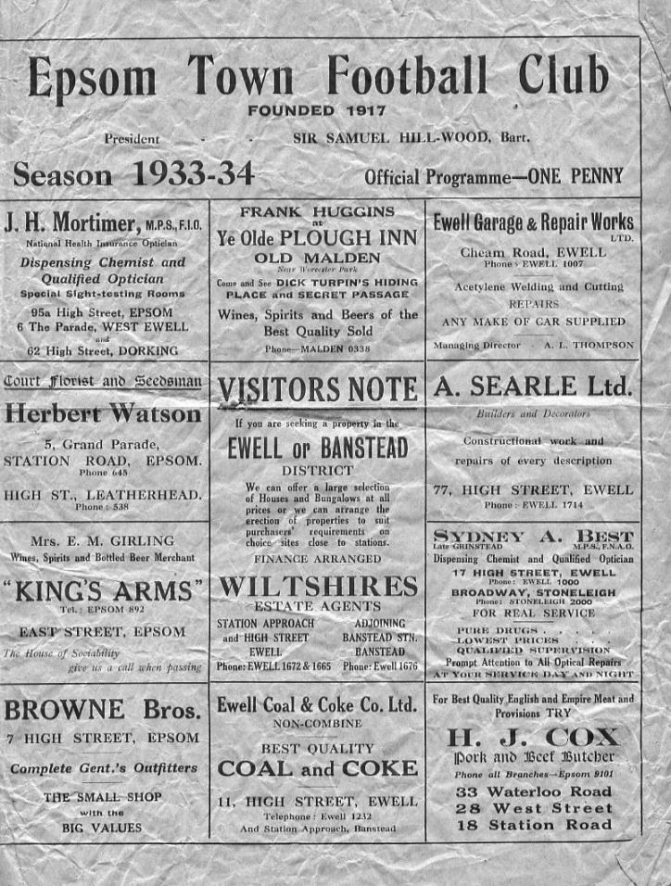
50 years ago this week came an indication of how far we had fallen in ten years as we were held 1-1 by Southern Amateur League club Ulysses at West Street in the Amateur Cup. We would triumph eventually in the replay at Raynes Park by 3-1 but would require extra time to even do this and were unable to negotiate the easiest of paths to the final qualifying round, losing in a replay to little Surrey Senior League club Lion Sports!

30 years ago this week we departed the F.A. Cup 3-0 at Imber Court to Met Police. In the thirty years since, we have only reached the Second Qualifying round on two more occasions, when we would lose in a replay to Banbury United in 1998 and when losing heavily at Horsham in 2000.

20 years ago this week we were held 2-2 after extra time by Tunbridge Wells in the F.A. Vase and worse was to follow as we just didn’t turn up to the replay three days later and were stuffed 3-0!

From behind the goal
Farnham Town 0-0 Epsom & Ewell
Combined Counties League - Premier Division - Saturday 16th September 2017

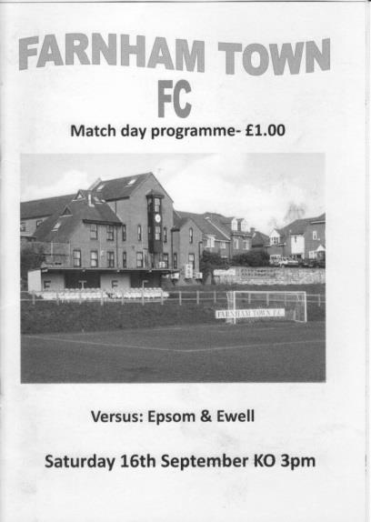
4,000th match ends with a hard earned point

It rained heavily both on the way to Farnham and on the way back. Timing is everything though, and in between the showers the spectators at the Memorial Ground were rewarded with a fully committed match in warm sunshine that you just couldn't take your eyes off.

There were a few changes to our line-up, following Tuesday's defeat against Horley Town. Up front Kyle Hough was unavailable so Rob Hendry moved into a more central role with Liam Roberts coming in on the left hand side. In place of the absent Dan Rose was Dale Marvell, while at the back we changed both our full backs as Jamie Hatfield had recovered from injury and Adam Heagney has re-joined our club, slotting straight in with Ben Hayward absent and Ben Dyson rested. Hatfield assumed the Captain's armband for the first time in over three years.

Although there was a certain significance about this being our 4,000th senior competitive match, there was no time to think about this as we needed a good result to avoid a larger gap at the bottom opening up. However, it nearly started in the worst way possible as the home team overlapped on the right wing and a stinging drive across goal flew away to safety off our far post with just 15 seconds on the clock!

We had to spend a fair bit of time in the opening twenty minutes clearing the ball away but looked quite dangerous going forward too. Roberts in particular was catching the eye with some good runs and although he could have delivered the ball sooner on occasions, we did pick up a number of free kicks around the Farnham box as their defenders were quite insistent on nobody getting past them!

Unfortunately our deliveries were not good enough to cause trouble. Joe Loftus-Cheek nearly made something out of nothing when a Roberts free kick came in low and he flicked the ball just beyond the far post and later in the half he headed a right wing cross just wide of the post but the majority of our opportunities were easy for Farnham keeper Jamie Cunningham to deal with. Cunningham had played against us once before, for Frimley Green in Lyndon Buckwell's last match in charge in 2014 when he became just the fourth keeper in ten years to deny Hough from the penalty spot, and that match finished goalless also!

Hendry saw his low drive dragged across goal from the edge of the area but we had concerns at the other end too and two strikes from the edge of the area were well blocked by our

defenders before the loose ball was driven in and was well saved by Colin Harris. He made another great save just as the first half came to a close when he got a hand to a far post header from a corner.

The second half commenced with a couple of nasty fouls, one from Josh Stepney which left Scott Murphy in a heap and then three minutes later when Marvell was late in the middle of the park; both of which earned yellow cards. This aside though it was a very sporting encounter and we were soon back concentrating on the football as the subsequent free kick was delivered to our far post where a powerful volley was tipped over by the well positioned Harris from just ten yards out. In response we nearly took the lead in the 63rd minute when Roberts found Marvell in space nearly thirty yards out and he beat a man before unleashing a left footed drive that flew down off Cunningham's crossbar and away to safety. The ball bounced a few inches away from the goal line as it came down.

Two minutes later Heagney was beaten to a high ball on the edge of his box but with the attacker bearing in on goal Reisse Griffin made a superb tackle to send the ball out for a corner which was somehow headed wide from a few yards out. Cristian Castell came on for Roberts and managed to get a volley on goal after Hendry had delivered a good ball to the far post but Cunningham made the save.

As we got into the final twenty minutes of the match things began to get a bit stretched. The home side pushed us back a little and from a corner on the right two strikers got in the way of each other with the ball being headed wide from close range again. There was then a bit of panic after Harris lost the ball but was thinking quickly and was able to kick it against a striker to earn a goal kick. Harris remained busy, saving low down as a shot came in through a crowd of players and being alert to block the follow up from a narrow angle with his feet.

However, from the corner in the 86th minute we had one of the biggest scrambles in front of goal that I've ever seen as the ball wasn't cleared. Bodies were diving in to block shots and as I lost sight of the ball from my position I feared the worst, awaiting what appeared to be an inevitable cheer as the ball hit the net, but it never came and eventually it was laid back to a home player who then drove the ball across goal from all of six yards. It was an incredible escape!!

And in the end maybe we deserved that bit of fortune. Neither side had given an inch during the contest and a win for one would have been harsh on the other as somehow it finished goalless. When you consider that we were missing Hough, Rose and Hayward from our line-up it was vital that we didn't slip any further behind at the bottom of the table and so the players deserve a lot of credit, especially for earning our first clean sheet of the season. Griffin had arguably his best game for the club here and many others played well also.

They say that football is all about the goals, but as 0-0 draws go, this was one of the more exciting ones!

Epsom and Ewell: Colin Harris, Adam Heagney, Jamie Hatfield (c), Scott Murphy, Reisse Griffin, Dale Marvell, Liam Roberts, Ashley Thompson, Rob Hendry,
Joe Loftus-Cheek, Jason Nwachukwu

Subs: Cristian Castell for Roberts (69), Sean White for Loftus-Cheek (79),
Alex McKay for Hatfield (84)

Centre page for results

Centre page for results




Hanworth Villa F.C. – History
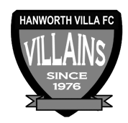
Hanworth Villa were formed in 1976 following a managerial disagreement at another long established Hanworth club. In the early years the team struggled in Division One of the Hounslow & District League, scoring a goal was usually celebrated with a public holiday. During the close season and following hard work by Jimmy Connors, who rebuilt the team, they finished Division One Champions.

The following season saw the club start an incredible run in the league, which finished 68 matches later, with 'The Villains' winning the Hounslow Premier League, and the West Middlesex Division One and Two Championships. The success continued with Hanworth being elected to the newly formed Middlesex County Football League.

From 1980 the club had a nomadic existence but in 1997 moved to its existing Headquarters at Rectory Meadow. This move led to the formation of Hanworth Villa Sunday, and later a reserve team, being an amalgamation of teams from - The Sawyers Arms, The Queen Dowager, and Feltham Railway Club, not that the lads like the odd beer! A Chiswick League double in 1993 and a 19-0 Cup Final victory in the National Railways Cup (did the opposition run out of steam?) cemented the successful amalgamation.

Following hard work by Dave Brown the club was granted a lease at Rectory Meadow. At last we had a permanent home and could set about converting an existing pavilion into a clubhouse, which has become known locally as “The Ranch”. With a permanent base we were able to concentrate on improving our football, and recent years have seen all our teams win numerous trophies, the most notable performance being by our Sat 1st team who landed “the treble” in 02/03, winning the Middlesex County Premier league, the Open Cup and the League Cup. After another premier league title in 2004/05, this time with a record number of points, it was decided that it was time to move on and the club were elected to Division One of the Combined Counties League in time for the start of the 05/06 campaign.

The Combined Counties Experience
It took a while to adapt to the new level of football, but in our second season we managed to win the Challenge cup. The following season, 2007/08, we successfully managed to defend the Challenge Cup and narrowly missed out on the league title, finishing a creditable second; our facilities however, prevented our promotion into the Premier Division. The club were determined to ensure that that situation wouldn’t arise again, and, with typical determination, the committee managed to raise the funds to ensure that floodlights and a spectator stand were installed in time for the start of the 08/09 campaign. The effort wasn’t in vain as we once again finished second in what was a very tight end to the season with the top 5 sides being separated by just 3 points. After a successful ground inspection we were promoted to the CCFL Premier in time for the 2009/10 season.

Our debut season in the Premier proved to be as difficult as we expected. Points were few and far between for the first half of the season, but we gradually started to come to terms with the improvement in standard required, and we managed to put together performances worthy of a CCFL Premier side. By the end of the season we had obtained enough points to finish in 17th position, 3 clear of the relegation places.

That 1st season taught us a lot and changes put in place during the close season allowed us to have a more comfortable second season, in which, we not only finished a creditable 5th in the league, but also reached the finals of the Middlesex Senior Charity Cup and also, for the 2nd consecutive season, the Southern Combination Cup. Unfortunately we lost out by the odd goal in both finals.

2012/13 saw us finish 3rd in the CC FL our highest ever position in the football pyramid since we were formed in 1976. There was also a very creditable run in both the FA Cup and Vas competitions. In the FA Cup we just lost out to AFC Totton 3-2 missing our on a first round proper tie with Bradford Park Avenue. Our run in the FA Cup saw wins over Shrivenham, Bedfont Sports, Wembley, Aveley and Slough Town. In the FA Vase we lost out to Herne Bay one of the beaten semi-finalists at the third round stage.

The 2013/14 season contained a top ten finish and another good F.A. Vase run although last season was a battle throughout, only surviving at the end after a good end of season run. At the end of the 2015/16 season the club appointed former Queens Park Rangers and Fulham defender Rufus Brevett as their new manager. Rufus had previously managed at Arlesey Town and had coached at Banbury United.

Last season Hanworth Villa finished in 3rd place in the league, the highest position obtained by the club in their history.

First Eleven Appearances 2017/18 - (max 10)
Name | Debut | 2016/17 |  |  |  | Career Totals
Name | Debut | App | Sub | Total | Goals | App | Sub | Total | Goals
AJAYI Tayo | 06/08/2017 | 3 | 2 | 5 | 1 | 3 | 2 | 5 | 1
BROOKS Jordan | 06/08/2017 | 3 | 0 | 3 | 0 | 3 | 0 | 3 | 0
CASTELL Cristian | 06/08/2017 | 2 | 2 | 4 | 0 | 2 | 2 | 4 | 0
DEWAR Ali | 29/10/2011 | 1 | 1 | 2 | 0 | 56 | 41 | 97 | 10
DYSON Ben | 12/08/2017 | 8 | 0 | 8 | 0 | 8 | 0 | 8 | 0
GRAHAM Bentley | 09/02/2016 | 1 | 0 | 1 | 0 | 18 | 1 | 19 | 3
GRIFFIN Reisse | 08/08/2015 | 8 | 0 | 8 | 0 | 81 | 13 | 94 | 6
HARLAND-GODDARD Tom | 06/08/2017 | 1 | 1 | 2 | 0 | 1 | 1 | 2 | 0
HARRIS Colin | 04/08/2012 | 8 | 0 | 8 | 0 | 33 | 0 | 33 | 0
HATFIELD Jamie | 11/11/2006 | 2 | 1 | 3 | 0 | 251 | 14 | 265 | 6
HAYWARD Ben | 07/03/2007 | 5 | 1 | 6 | 0 | 248 | 29 | 277 | 18
HEAGNEY Adam | 16/08/2016 | 1 | 0 | 1 | 0 | 38 | 9 | 47 | 1
HENDRY Rob | 08/08/2015 | 6 | 0 | 6 | 3 | 74 | 22 | 96 | 26
HOUGH Kyle | 14/08/2007 | 6 | 2 | 8 | 4 | 339 | 21 | 360 | 205
JARMAN Mark | 08/08/2009 | 0 | 0 | 0 | 0 | 136 | 51 | 187 | 76
LAW Franky | 06/08/2017 | 3 | 0 | 3 | 0 | 3 | 0 | 3 | 0
LOFTUS-CHEEK Joe | 06/08/2017 | 9 | 0 | 9 | 2 | 9 | 0 | 9 | 2
MARVELL Dale | 15/01/2000 | 6 | 2 | 8 | 0 | 275 | 51 | 326 | 86
MCKAY Alex | 20/12/2008 | 0 | 1 | 1 | 0 | 131 | 38 | 169 | 12
MURPHY Scott | 20/01/2007 | 5 | 0 | 5 | 0 | 17 | 2 | 19 | 1
MYERS Antony | 23/12/2006 | 1 | 0 | 1 | 0 | 76 | 33 | 109 | 9
NWACHUKWU Jason | 01/10/2016 | 7 | 2 | 9 | 0 | 24 | 18 | 42 | 1
O'BRIEN Louis | 28/08/2017 | 1 | 2 | 3 | 0 | 1 | 2 | 3 | 0
ROBERTS Liam | 12/08/2017 | 3 | 4 | 7 | 0 | 3 | 4 | 7 | 0
ROBINSON Sam | 22/10/2011 | 5 | 0 | 5 | 0 | 66 | 6 | 72 | 14
ROSE Daniel | 25/10/2016 | 5 | 1 | 6 | 0 | 7 | 6 | 13 | 0
SMITH Andy | 25/08/2017 | 2 | 0 | 2 | 0 | 2 | 0 | 2 | 0
THOMPSON Ashley | 21/08/2017 | 5 | 1 | 6 | 0 | 5 | 1 | 6 | 0
THOMSON David | 02/09/2017 | 2 | 0 | 2 | 0 | 2 | 0 | 2 | 0
TURPIE Alistair | 31/03/2016 | 0 | 0 | 0 | 0 | 11 | 1 | 12 | 0
WHITE Sean | 02/08/2014 | 1 | 4 | 5 | 1 | 7 | 17 | 24 | 4
* Player has left the club

Every Opponent A-Z

Over the years we have played many, many different opponents. Exactly how many is a difficult question, as it all depends on your definition. Are Camberley & Yorktown different to Camberley Town, or are Epsom Town different to Epsom F.C. or Epsom & Ewell F.C.?

In my analysis I have classed both of the above examples as the same team, and will work through them all from A to Z. Some we have played many times, whilst others we have met just once or twice. Enjoy!

West Norwood: Played 14 - W8 D2 L4 - F38 A23 - PPG - 1.86 - Good

West Norwood were a very old club by the time we met in the twenties. In fact, they were so old that they had even played an earlier forerunner of ours, Ewell F.C. way back in 1896/97!

Ewell had been founded in October 1890 thanks to John Henry Bridges and a couple of Full England International players, Arthur Melmoth Walters and Percy Melmoth Walters, or morning and afternoon (AM and PM) as they became known, played a few matches for their country with Percy Captaining on occasions. However, within two months of founding Ewell F.C. they suffered the tragic loss of their younger brother Hugh, aged just 22 in a football match and retired from International football, although they would play at top Amateur level for a while yet with Arthur playing in the Old Carthusians team that won the first Amateur Cup in 1894.

By that time Ewell were a senior status club, having won the Surrey Junior Cup in 1894 without the assistance of the Walters brothers and by a record score that has yet to be surpassed, 6-0 over Balham Wanderers. As a Senior club, in those days there were three large competitions available with the majority of other matches being friendlies. Ewell never entered the Amateur Cup but there was the Surrey Charity Shield - later named the Surrey Senior Shield, and the Surrey Senior Cup. Ewell were good enough to reach the final of both competitions in their brief history but a couple of years before that, they had a bit of a saga with West Norwood, complaining about the conditions before the game at their ground, High View Park as they visited on 5th December 1896.

Despite this Ewell took the lead through regular talisman Alec White but upon conceding twice in the second half they must have complained again and the referee abandoned the match, commuting it to a friendly. Ewell protested that a replay should be allowed at West Street while the opposition protested that the result should have stood in the first place! There were also complications as Ewell had a player on the SCFA Committee in R.S. Dally!

A replay was awarded but it was decided that the match should again be played at the original ground on 9th January. Eventually it was postponed anyway and then determined that if it was not able to be played on 16th January at West Norwood, it would be switched to Ewell, which duly happened with the home side winning 3-1 in front of 500 spectators. The matter still wasn’t over though and West Norwood protested upon the eligibility of one of our top players Barry Porter, who hadn’t played in the original fixture. This was upheld by SCFA and the match was then re-scheduled back at West Norwood, whereupon the Ewell team withdrew from the competition!

West Norwood went on to become one of the early members of the Isthmian League, joining in 1907 and by now playing at the Herne Hill Cycle track which still exists to this day, but they couldn’t stay and this forced them to leave the prestigious “top table” and they were an Athenian League club by the time they first met Epsom Town on 25th October 1924 at Gorringe Park which was at the Northern end of Figges Marsh in Mitcham. We had actually been drawn at home in our first ever Amateur Cup tie, but as our ground at Horton Hospital wasn’t able to be enclosed, no gate

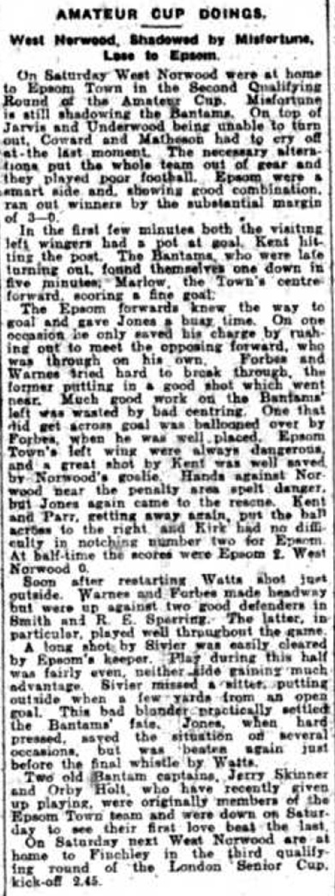
could be taken and we had to concede home advantage. It didn’t matter though as Reg Marlow scored twice and Tom Kirk got the other in our 3-0 win.

You will note from the enclosed South London Press report that we had a couple of players from an earlier incarnation of Epsom F.C. Arthur ‘Orby’ Holt and Syd Skinner, the youngest of a family of players that had been unable to fulfil their potential at Epsom’s junior level back then.

By a quirk of fate West Norwood would also become our first ever F.A. Cup opponents on 19th September 1925, winning 1-0 at Streatham Road, Mitcham, where they were ground sharing with Mitcham Wanderers with Sid Bristow missing a penalty in a match we dominated.

We beat them again at home in the Amateur Cup 2-1 on 13th November 1926 with Marlow and Bronk Challis scoring our goals and it was Marlow again who put them to the sword the following season as we won 4-1 in the F.A. Cup. This time the roles had reversed as we had been drawn away but with West Norwood minus a ground that year, they came to West Street.

With the two teams in different leagues it was odd how often we were paired together and in 1930/31 we won 3-2 in the Amateur Cup in another match switched to West Street, although they knocked us out of the FA Cup again in 1931/32, yet again in a switched match at our old home.

We returned the favour in the FA Cup the following season by a more comprehensive 5-1 before meeting for a couple of friendlies, the latter of which on 22nd February 1936 was billed as a farewell for regular keeper Jack Forster who was returning home to his native North East, although their striker Ray Mason spoiled his day somewhat by scoring all seven goals in a bizarre 7-6 win!!

In 1936/37 we were coming off a poor season, although it had been worse for them as the Athenian League had cut them loose, much as they would do to us in 1973. They met us in the London League at the start and end of the season, drawing 3-3 in the August of 1936 but with Epsom winning 3-0 in late April at Sandy Lane where they were by now sharing with Tooting & Mitcham United.

In 1937/38 they left for the Surrey Senior League where they would meet our tenants Ewell and Stoneleigh; a short lived club that spent two seasons there. Our tenants won both matches in the league but met twice more in cups, sharing the spoils. Ewell and Stoneleigh’s last ever match was a 9-0 win over West Norwood on Thursday 5th May 1938 before folding. Quite a way to go out!

West Norwood carried on for one more season and we were drawn together in the F.A. Cup for the final time, meeting on 17th September 1938 with our boys winning 2-0 with goals from Jimmy Jones and Basil Solly and a year later the club closed down, originally for World War Two, but never to return. It was a sad end to a very famous club from the very early days and a cautionary tale of one that had no ground of their own for so long, that it eventually wore them down.

Combined Counties League Premier Division
Opponents All-time Records
inc Saturday 16th Sept | P | W | D | L | F | A | PPG | GD | Best  Win | Worst  Loss
Godalming Town | 1 | 1 | 0 | 0 | 2 | 1 | 3.00 | +1 | 2-1 | X
Abbey Rangers | 4 | 3 | 0 | 1 | 11 | 4 | 2.25 | +7 | 7-1 | 2-3
Sutton Common Rovers | 13 | 9 | 2 | 2 | 30 | 19 | 2.23 | +11 | 4-0 | 0-5
Horley Town | 31 | 21 | 5 | 5 | 69 | 34 | 2.19 | +35 | 6-0 | 1-3
Spelthorne Sports* | 8 | 5 | 2 | 1 | 16 | 11 | 2.13 | +5 | 6-2 | 1-5
Bedfont Sports | 11 | 7 | 2 | 2 | 21 | 12 | 2.09 | +9 | 5-1 | 0-4
Banstead Athletic | 38 | 23 | 7 | 8 | 62 | 38 | 2.00 | +24 | 5-0 | 0-4
Knaphill | 8 | 5 | 1 | 2 | 17 | 9 | 2.00 | +8 | 4-0 | 1-2
Guildford City | 18 | 11 | 1 | 6 | 35 | 22 | 1.89 | +13 | 5-1 | 1-5
Westfield | 21 | 12 | 3 | 6 | 43 | 36 | 1.86 | +7 | 6-1 | 0-4
Colliers Wood United | 24 | 14 | 2 | 8 | 47 | 39 | 1.83 | +8 | 4-0 | 0-5
Farnham Town | 16 | 8 | 4 | 4 | 27 | 25 | 1.75 | +2 | 3-1 | 1-4
Hanworth Villa | 17 | 8 | 4 | 5 | 38 | 27 | 1.65 | +11 | 5-0 | 1-4
Walton & Hersham | 52 | 25 | 11 | 16 | 105 | 99 | 1.65 | +6 | 8-0 | 1-9
Camberley Town* | 90 | 38 | 22 | 29 | 158 | 125 | 1.51 | +33 | 9-1 | 0-4
Redhill | 34 | 14 | 2 | 18 | 63 | 74 | 1.29 | -11 | 7-2 | 2-8
Chertsey Town | 50 | 19 | 5 | 26 | 77 | 94 | 1.24 | -17 | 3-0 | 0-7
North Greenford United | 12 | 4 | 2 | 6 | 18 | 22 | 1.16 | -4 | 3-0 | 1-4
AFC Hayes | 10 | 2 | 3 | 5 | 18 | 18 | 0.90 | 0 | 7-0 | 0-3
CB Hounslow United | 4 | 1 | 0 | 3 | 6 | 11 | 0.75 | -5 | 2-0 | 1-5
Balham | - | - | - | - | - | - | - | - | - | -
* includes one abandoned match v Camberley and one loss on penalties v Spelthorne
Birthday corner – September – A busy month!
It isn’t so much Birthday corner this week, it’s more like an entire room full as we have an incredible nine players of the 32 registered currently that have a birthday in the month of September. Although there will be no birthday cake, we at least want to avoid any Yaya Toure moments by wishing them all a Happy Birthday!


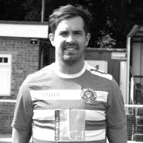
I shall start with the 1st of September when our Club President Stella Lamont was 89. Although she hasn’t been to a game for a few years, she still follows the club avidly from afar.

Moving on to the 2nd of September, when Sam Robinson was 28. Sam has been with us on and off since joining back in October 2011 and has clocked up 72 appearances in that time with 14 goals.

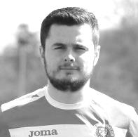
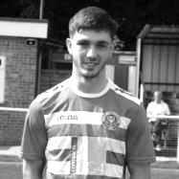
On 6th September Bentley Graham turned 27. He spent a bit of time with us in the 2015/16 season before moving on to Whyteleafe last season. However, he has returned to us recently and once recovered from injury he will become an integral part of our midfield. He has 19 appearances and 3 goals for us since making his debut at Camberley Town on 9th February 2016.

Turning now to one of our newer recruits, Liam Roberts celebrated his 20th birthday on 11th September. Liam has made seven appearances for the club so far and looks to be growing into his role on the flanks in the same way that Jordan Gallagher did last year.

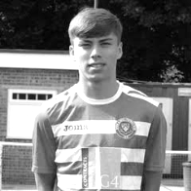
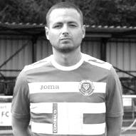
Ben Dyson was 19 on the 15th of September and is another of our young lads who joined from the Leatherhead Under 21s Academy. He has been thrown in at the deep end this season but will be better for the experience and I’m sure will become a valuable member of the team very soon, having already made eight appearances this season.

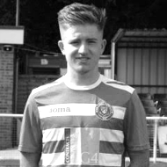
From Youth to experience now as Jamie Hatfield was 31 on Monday 18th September. He has now made 265 appearances for us since making his debut on 11th November 2006, which places him 19th on our all-time list. Incredibly we have three current players who sit above him in Ben Hayward (277), Dale Marvell (326) and Kyle Hough (360).

Another of our youngsters Louis O’Brien was 20 on Tuesday 19th September. Another product from the Leatherhead Academy, he has three appearances to his credit now.

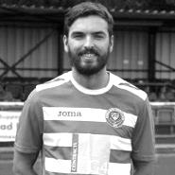
Onto the 21st September now where Dan Rose was 28. Dan joined us midway through last season but was then injured at work so it is good to see him back playing again now. Dan has 13 appearances for our club now.

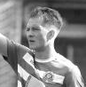
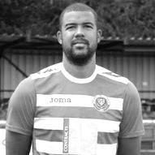
Yesterday Franky Law celebrated his 24th birthday. He was a regular at the start of the season but has been away recently.

Finally, Ashley Thompson celebrates his 28th birthday tomorrow. Ashley joined us from Banstead Athletic soon after the start of the season and is playing a valuable holding midfield role. He has six appearances to his name so far.

Match and Ball Sponsorships – 2017/18
Opponent | Date | Match Sponsor | Ball Sponsor
Banstead Athletic (FAC) | 06/08/17 | Club President - Stella Lamont
Chertsey Town | 15/08/17 | EEFC Management Committee
Redhill | 02/09/17 | Building Shop Ltd
Spelthorne Sports | 09/09/17 | In memory of Betty Dyke
Horley Town | 12/09/17 | Alex McKay (Senior)
Hanworth Villa | 23/09/17 | Jack Jarman
North Greenford United | 28/10/17
Godalming Town | 11/11/17
Farnham Town | 14/11/17 | In memory of Dave and Lizzie Marshall
Guildford City | 02/12/17
Abbey Rangers | 16/12/17
Walton & Hersham | 30/12/17
Balham | 20/01/18
Sutton Common Rovers | 03/02/18
CB Hounslow United | 13/02/18
Knaphill | 24/02/18
Camberley Town | 10/03/18
Bedfont Sports | 24/03/18
Colliers Wood United | 30/03/18
Banstead Athletic | 02/04/18 | Nathan Lambert – 10 years old today!
Westfield | 14/04/18
AFC Hayes | 28/04/18 | Club President - Stella Lamont
F.A. Vase 1st Round Proper |  | Unknown opponents
For League, League Cup and Surrey Senior Cup Matches:
Match sponsorship - £40.00 Match ball sponsorship - £25.00. Combined £55.00.
For F.A. Cup and F.A. Vase matches:
Match sponsorship - £50.00 Match ball sponsorship - £30.00. Combined £65.00.

Sponsorship includes: (x2 for match, x3 for match and ball)

Admission, programmes, hospitality and advertising and mascot for the day (if required).

If you are interested, just speak to a Committee Member, or drop me an email at: richard.c.lambert@gmail.com

We also thank our Kit Sponsors
G4 Group

Salts Super Six Predictor
The Salts Super Six Predictor is live again today and the tickets are on sale at today’s game to the left of the gate. The matches are to be played today.

The jackpot is now up to £540 which if won would represent the largest individual prize so far and who knows how much higher it could rise!

The competition is easy to play! To win, you simply need to predict the results of six matches correctly from the three options, fill in the form and make sure it is back with our seller before the deadline on the ticket. The latest fixtures are shown below.

If you are a club regular, you just need to place your name on the sheet, although if you aren’t, then we’ll need a contact number from you too. We will announce any winners on the website within three working days, so don’t worry, we won’t miss you!

Please note that if there is more than one winner, the prize pot would be shared between the winners. All you need to do now is have a go, as many times as you like!

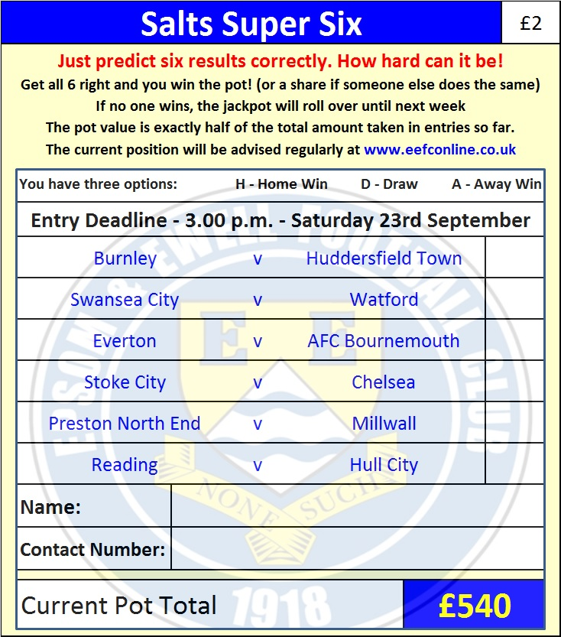

Good luck!

Combined Counties League – Premier Division
Saturday, 23rd September 2017 - Kick-off 3.00 p.m.
Epsom and Ewell  (Royal Blue & White hoops) | V |  | Hanworth Villa  (Red / White)
Squad | NUMBERS |  | Squad
Colin Harris |  |  | Michael Eacott
Adam Heagney |  |  | Thomas Tristan
Jamie Hatfield |  |  | Adam Baigent ©
Reisse Griffin |  |  | Felix Ahorlu
Scott Murphy |  |  | Jack Buckle
Dale Marvell |  |  | Francis Darko
© Ben Hayward |  |  | Tom Dilloway
Ashley Thompson |  |  | Steve Loveridge
Kyle Hough |  |  | Dan Milborrow
Joe Loftus-Cheek |  |  | Jack Mills
Rob Hendry |  |  | Luke Muldowney
Jason Nwachukwu |  |  | Tom Neale
Liam Roberts |  |  | Chris Ogunlana
Ben Dyson |  |  | Jermaine Queensborough
Sean White |  |  | Cyril Ocansey
Jordan Brooks |  |  | Athan Smith-Joseph
David Thomson |  |  | Levi King
Daniel Rose |  |  | Alfie White
Tayo Ajayi |  |  | Luke Silavke
Ali Dewar |  |  | Junior Wright
Louis O’Brien |  |  | Ade Oshilaja
Alistair Turpie |  |  | Jesse Atiaise
Sam Robinson |  |  | Michael Vincent
Andy Smith |  |  | Simon Malumba
Glyn Mandeville | MANAGER |  | Rufus Brevett
 | ASSISTANT |  | Bobby Watson
Alex McKay / Jimmy Hendry | COACHES / PHYSIO |  | Cliff Angol / Elliot Atiase
REFEREE: A.Jallow
ASSISTANTS: P.Crichlow, I.Hempel
Today’s Match and Match Ball are kindly sponsored by:
regular supporter Jack Jarman

OUR NEXT VISITORS TO HIGH ROAD
Unknown – check website
Saturday 21st October or Saturday 28th October 2017

